Project Design Phase-II
Technology Stack (Architecture & Stack)
Date | 20 February 2026
Team ID | LTVIP2026TMIDS70689
Project Name | HouseHunt: Finding Your Perfect Rental Home
Maximum Marks | 4 Marks

Technical Architecture Diagram:
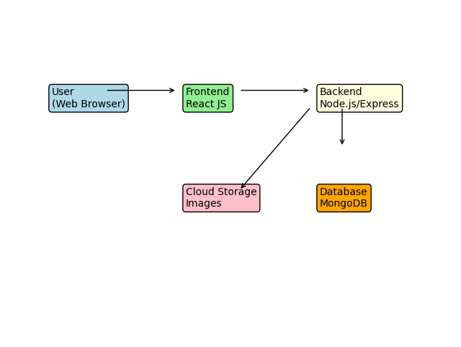

Table-1: Components & Technologies
S.No | Component | Description | Technology
1 | User Interface | Web interface for users | HTML, CSS, JavaScript, React JS
2 | Application Logic | Handles requests and responses | Node.js, Express JS
3 | Database | Stores user & property data | MongoDB
4 | File Storage | Stores property images | Cloudinary/Local Storage
5 | External API | Maps/location services | Google Maps API
6 | Infrastructure | Deployment environment | Localhost / Cloud (Render/Netlify)

Table-2: Application Characteristics
S.No | Characteristics | Description | Technology
1 | Open Source Frameworks | Frontend & backend frameworks | React JS, Node.js
2 | Security | Authentication & data protection | JWT Auth, Encryption
3 | Scalable Architecture | 3-tier architecture | Frontend-Backend-DB
4 | Availability | 24/7 access | Cloud Hosting
5 | Performance | Fast data loading | Optimized queries

